Alexa Testing Guide

Important Notes
Automated voice testing is a custom-made support done through the C# harness. It’s not a built-in features of TestArchitect.

Configure TestArchitect
- TestArchitect needs to be up and running in a Windows box.
- Be sure to have Microsoft .Net 4.5 installed
- After decompressing the file voice.zip, copy file TestAchitect.Harness.Bundle.Voice.dll to {INSTALL_DIR}\harness samples\csharp\executables\bundles

- Right click on dll file, and select “unblock”:
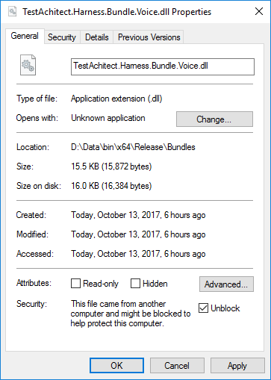

Make Sure Alexa is ready
We’re going to ask Alexa to solve a very complex math problem “Alexa, what is 5 times 2” and Alexa should better say “5 multiplied by 2 is 10”

Test Drive
- Create a repository, then a project and finally a test module
- From the test editor, enter these action lines:

(Don’t worry as you see actions ‘start convo’ and ‘end convo’ are marked with red color)

- Click on button to open the Execution Dialog. On that dialog, click on Automation Tools, then select ‘TestArchitect CSharp Harness’ from the Playback Tool dropdown list

- Press F9 to execute test. The test should pass:

- Click on ‘View detailed results per test line’, the HTML report should look like this:
That’s it!

